Wind and Storage

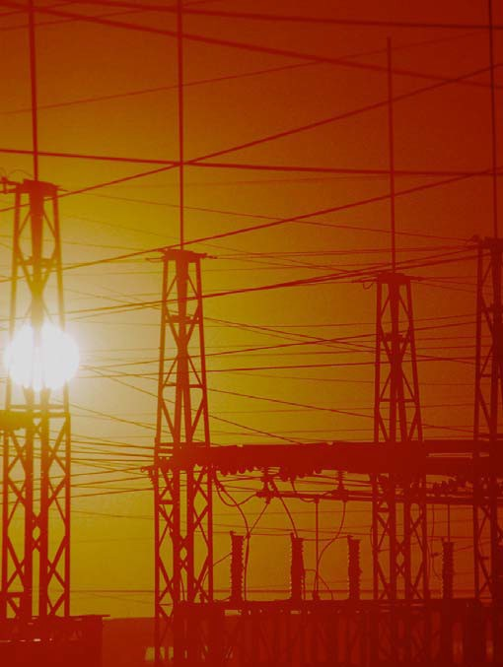

TCIPG Educational Development
TCIPG: Trustworthy Cyber Infrastructure for the Power Grid

Wind and Storage

Comments for Teachers
The applet at http://tcipg.mste.illinois.edu/applet/ws allows the user to explore effects on the transmission system as communities demand more power, and wind generation is added or increased.
Encourage students to explore the applet. Then use the lessons on the student pages to focus their investigations.
When the applet opens, a coal powered generator and a natural gas generator are available to deliver electricity to three communities, but only the coal generator is producing. The wind farm is not yet connected to the system. As the demand from the communities changes over a 24-hour period, the generators automatically adjust their power production.

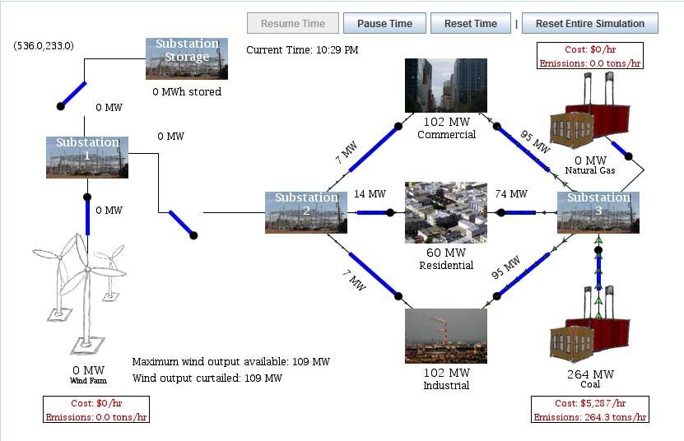

Lesson 1

The demand from the communities (power professionals call the users of electricity “loads”) varies throughout the day. Every time a person turns an appliance off or on the demand changes, but the total for the whole

community follows a predictable pattern. The residential community increases its demand for electricity for a few hours in the morning and again in the late afternoon. The commercial community uses more electricity between 6:00 AM and 6:00 PM, and the industrial community’s highest demand is between 8:00 AM and 4:00 PM. The applet uses data from the Energy Information Administration to create a profile for an average day for each type of community. Users can click the Pause Time button to view the system at an particular instant.
When the applet opens or is reset, the Peak community power demand is set to be 750MW. This means that in this scenario the total demand from all three communities never exceeds 750 MW. You can use the slider to increase or decrease this maximum or peak.
More Resources
- The Energy Information Administration provides Official Energy Statistics from the U. S. Government. This agency was created by Congress in 1977 to provide unbiased energy information. http://www.eia.gov/
- Interesting alternative energy ideas http://www.power-technology.com/features/featureamps-with- attitude-bizarre-and-brilliant-alternative-power-sources/

Wind and Storage Lesson 1
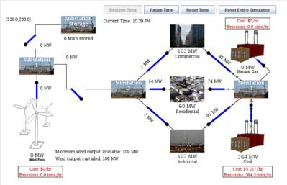
Use the applet at http://tcipg.mste.illinois.edu/applet/ws to explore some issues related to generation, demand, and transmission of electricity.
When the applet opens a coal powered generator and a natural gas generator are available to deliver electricity to three communities, but only the coal generator is pro- ducing. As the demand from the communities changes you can see the generators adjust their power production.
You can also see fuel costs and carbon dioxide (CO₂) emissions per hour for each of the generators.
- Watch the clock and notice how the demand from the communities changes throughout the day. What do you see?

- At what times is the power demand from the residential load lowest? When is it highest?

1 MW is 1,000,000 watts or power demand equal to 1000 hairdryers. 1MWh of energy is needed to operate 1000 hairdryers for one hour.

- At what times are the power demands from the commercial load and industrial load lowest and highest?

- How does demand from the three communities differ?

When the applet opens or you click the Reset Entire Simulation button, it’s 12:00 midnight and the residential community is de- manding 60 MW of power. The total peak demand for all three of the communities is set to be 750 MW. This means that the applet will not allow the total demand from the three communities to ex- ceed 750 MW at any time.
This applet simulates a vertically integrated power utility. The utility operates generators and owns transmission lines to provide power to the three communities. Two generators are available to provide electricity, but as the communities grow and demand for electricity increases, the utility wants to add a wind farm to increase its generation capacity.
- At about what time is the peak demand?
- What happens when you move the Peak community power de- mand slider?

- At what demand level does the natural gas generator begin pro- duction?
- At what demand level can these two generators no longer meet the demand from the communities?

Wind and Storage

Comments for Teachers

Lesson 2

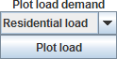
The generators in the applet at http://tcipg.mste.illinois.edu/applet/ws constantly adjust to the demand for electricity from
the three communities. Clicking Pause Time stops
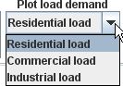
the applet and shows a snapshot of demand and production. Clicking Plot load shows a graph of the demand from a community beginning at 12:00 midnight. When the applet opens or is reset the Plot load button is set to open a graph for the Residential load. To change to another community, use the down arrow to the right of the Residential load label.
A 24-hour plot for the residential community shows an increase in use during the morning and another larger increase in the early evening. This pattern is generally true throughout the U.S. although there are seasonal variations and some communities may show shorter or longer peak periods.
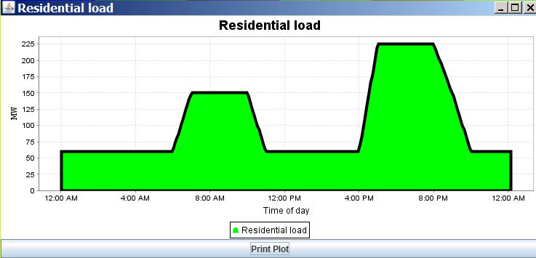
Power utilities encourage residential customers to consider moving some of their electricity use to the times of day when typical demand is lower. Some utilities are installing electricity meters that can record energy use hourly. These allow the utility to offer plans that charge lower prices when demand is low and higher prices at times when the demand is higher. There are a variety of these plans offered by various utilities.
More Resources
- Time of Use Electricity Billing. This article from Energy Priorities magazine tells about peak demand and provides a case study of Puget Sound Energy’s time of use billing http://energypriorities.com/ entries/2006/02/pse_tou_amr_case.php
- Power Smart Pricing is an hourly pricing program from the Ameren Illinois Utilities, administered by CNT Energy http://www.powersmartpricing.org/how-it-works/
- ConEdison (New York) offers a voluntary Time-of-Use program that charges customers a lower rate during weekends and holidays and on weekdays between 10:00 PM and 10:00 AM http://www.coned.com/ customercentral/energyresvoluntary.asp#quiz

Wind and Storage Lesson 2

Use the applet at http://tcipg.mste.illinois.edu/applet/ws to further explore how the de- mand for electricity varies during a day. When the applet opens or the Reset Entire Simulation button is clicked, the Current Time reads 12:00 AM and the demand for power is low. The coal generator is supplying all the needed power.
- Pause Time when the Current Time reads about 2:00 AM. How much power is each community

type demanding? Commercial
Residential
Industrial

- Resume Time. How is the demand for each community changing?
Power utilities must generate electricity just when the users need it. The applet shows the generators adjusting to the demand. Utilities and power professionals study when people typically use electricity and how much they use. System operators monitor demand and communicate with generation sites to be sure users of electricity get the power they need when they need it.

- Pause Time at about 7:00 AM. Now how much power is each community type demanding?

Commercial Industrial
Residential

- What might explain the changes in demand for each community?

Click the Plot load button at the bottom of the applet to see a graph showing the power demanded by the Residential load.
- Reset Time and watch the graph grow for 24 hours. Then Pause Time. When is the Residential load demanding the most power?
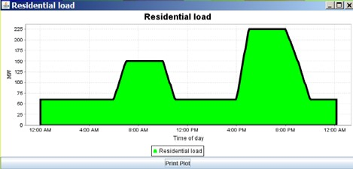
- During what times of day is the residential de- mand increasing?

- How do you see the power demand from the Resi- dential load changing during a 24 hour period?

Wind and Storage

Comments for Teachers

Lesson 3

Demand for electricity is constantly changing, but power utilities col- lect and study data for the total demand over time and know that there are predictable patterns of use. The demand from the communities in
the applet follows patterns based on data collected by the Energy Information Administration. For this simulation the patterns in the applet are the same for every day. The total demand for all three communities is usually highest in the late afternoon. Electricity providers need to be sure they have the ability to supply their customers during the peak time period. When you adjust the Peak community power demand slider the amount of electricity used increases, but the pat- terns of use stay the same. Changing the slider is like changing the population of the communities.
When the Peak community power demand is set at 750 MW the demand from three communities looks like the plots shown below. Each of theses shows a 24-hour period. The total of the three communities’ usage is 750 MW in the late afternoon.
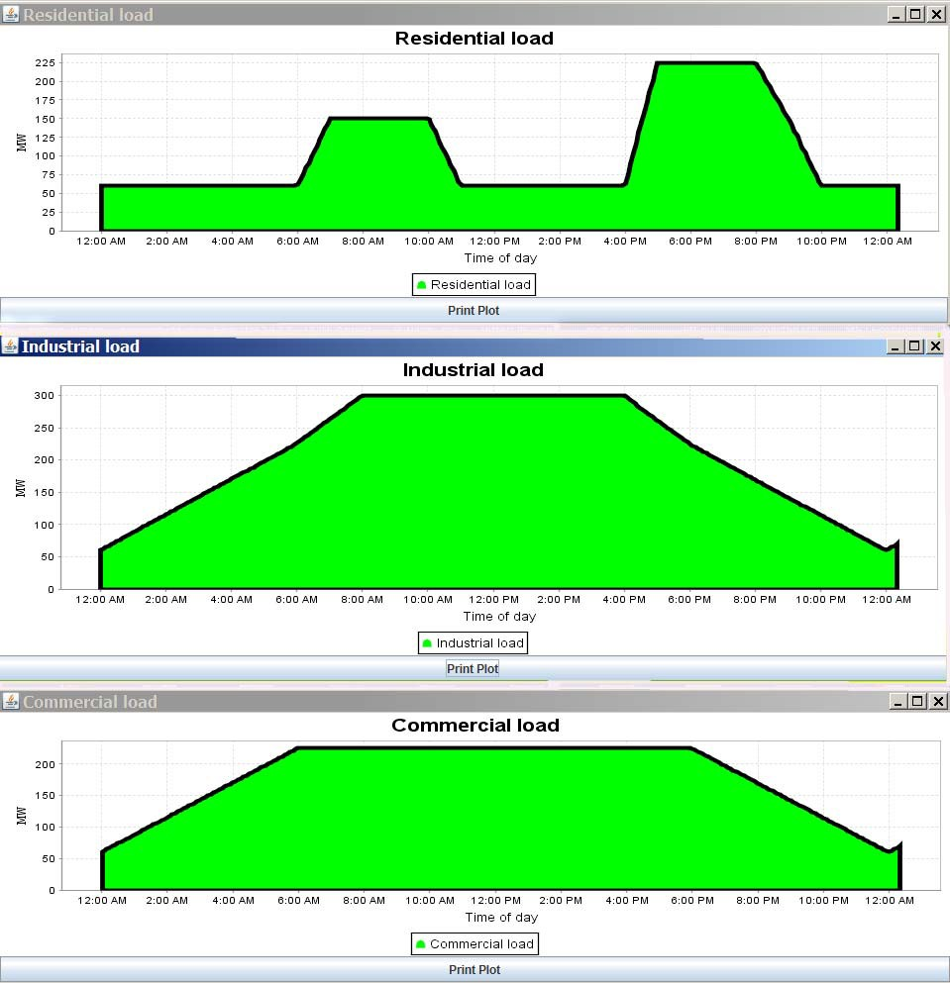

Wind and Storage Lesson 3
Use the Plot load capability in the applet at http://tcipg.mste.illinois.edu/applet/ws to ana- lyze how demand for electricity varies during a 24 hour day. Click the Reset Entire Simulation but- ton. Use the drop down menu above the Plot Load button to choose Industrial load. Then click Plot Load. Pause Time after a full day and resize the windows to see more detail.

- What demand pattern do you see over the whole day?
If 100,000 households
each turn on exactly six 100W light bulbs that power demand is

- Plot the Commercial load and the Residential load. Compare the 24 hour demand
plots for the three communities. How do the patterns of use differ? How are they similar?

- Complete the chart below.

Power Demand (peak 750 MW) | 12:00  AM | 4:00  AM | 8:00  AM | 10:00  AM | 12:00  noon | 4:00  PM | 5:00  PM | 8:00  PM | 10:00  PM
Residential Load
Commercial Load
Industrial Load
Total demand

- Set the Peak community power demand slider to 2000 MW and plot each of the loads and com- plete the chart below.

Power Demand (peak 2000 MW) | 12:00  AM | 4:00  AM | 8:00  AM | 10:00  AM | 12:00  noon | 4:00  PM | 5:00  PM | 8:00  PM | 10:00  PM
Residential Load
Commercial Load
Industrial Load
Total demand

- Power grid operators study the patterns of electricity use to help them plan. When do the gen- erators need to produce the most electricity?

Wind and Storage

Comments for Teachers

Lesson 4

The generation costs shown in this applet are fuel costs. Power utilities incur other costs that are not shown in this simulation. You can learn more transmission and distribution, operations and maintenance costs and
also more about CO₂ emissions in the Power Economics and Emissions applet at http:// tcipg.mste.illinois.edu/applet/eco.
The Wind and Storage applet simulates a utility that owns one coal generator and one natural gas generator. Each of these generators has the ability to supply 1500 MW of power. Within the con- straints of the transmission line capacities and the generator capabilities, the lowest cost genera- tion is used to supply the load. In the applet the coal generator costs less to operate than the natu- ral gas generator so it provides power until it reaches its maximum or until its transmission line reaches its maximum capacity. The applet opens with the coal generator supplying all the power to the communities. If the coal generator is disconnected from the system or if the communities de- mand more than 1500 MW of power, the natural gas generator supplies power. Electricity generated from coal is relatively inexpensive, but burning coal generates significant CO₂ emissions. Natural gas generators produce less CO₂, but they are more expensive to operate. Scientists and engineers are working to find alternative sources that compete with the cost of coal and yet have low or no emis- sions. Adding wind powered generation is one possibility, and the utility plans to add a wind farm.
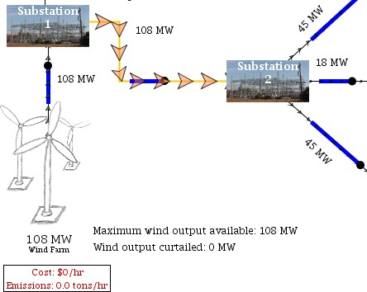
When the applet opens or is reset the wind farm is not connected to the system. The wind farm capacity is 195 MW, but the amount of power available varies with wind speed. Clicking the blue switch between substations 1 and 2 connects the wind farm to the sys- tem. The capacity of this transmission line is initially set to be 125 MW. When the maximum wind output available is more than 125 MW the excess wind power is curtailed. The arrows are large and orange when
the transmission line is at or near its capacity.
More Resources
- The Future of Coal, an interdisciplinary MIT study http://web.mit.edu/coal/
- What are greenhouse gases and how much are emitted by the United States This article from the Energy Information Administration briefly describes greenhouse gases, their sources and their effects on climate change. http://www.eia.gov/energy_in_brief/greenhouse_gas.cfm
- Energy Kids, Greenhouse Gases http://www.eia.gov/kids/energy.cfm?page=environment_about_ghg-basics
- U.S. Department of Energy, Energy Efficiency and Renewable Energy’s Wind Powering America Update, http:// www.windpoweringamerica.gov/filter_detail.asp?itemid=746

Wind and Storage Lesson 4
Explore some aspects of fuel costs and CO₂ emissions related to generation in the applet at http://tcipg.mste.illinois.edu/applet/ws. When the applet opens or the Reset Entire Simulation button is clicked, the coal generator is supplying all the necessary power to the communities.
- How is the generator’s cost to supply the power related to the amount of power produced?

- Use the Resume Time and Pause Time buttons to monitor costs and emissions related to the coal generator’s production. Complete the top portion of the chart. Then Reset Entire Simulation and open the switch from the coal generator so the natural gas generator is supplying the power, and complete the rest of the chart.
- Which generator produces power with lower fuel costs?

- Determine the cost per MWh for each generator.
Peak community power demand 750 MW
Approximate times | 4:00 AM | 8:00 AM | 12:00 noon | 5:00 PM | 10:00 PM
Coal generator
Production (MW)
Fuel Cost ($/hr)
Emissions (tons/hr)
Natural Gas generator
Production (MW)
Fuel Cost ($/hr)
Emissions (tons/hr)

Coal
N. Gas
- Which generator produces power with fewer CO₂ emissions?
The power utility wants to provide electricity to its customers at the lowest cost. It is also concerned about climate change and wants to
keep its CO₂ emissions as low as possible, so it wants to add wind power generation. The site with good wind resources is some distance from the communities so the utility needs transmission lines to connect to it. Click on the switch to close the line between substation 1 and substation 2.
- How much power does the wind farm contribute to the communities?
- How does this affect the costs and emissions?

Wind and Storage

Comments for Teachers

Lesson 5

There is a panel of buttons and sliders near the bottom of the applet at http://tcipg.mste.illinois.edu/applet/ws.
The sliders change:
- the peak community power demand
- the wind farm capacity
- the capacity of the transmission line from the wind farm.
The buttons show plots over time for:
- costs
- emissions
- maximum wind power available
- branch flow on eleven different transmission lines
- load demand from the three communities
- generation from the three generators and the storage device

This lesson uses the Peak community power demand slider and the buttons that Plot system costs
and Plot system emissions.
Keep in mind that this applet is not designed to consider construction costs for new power plants or for new transmission lines. System costs in the applet are totals of only fuel costs.
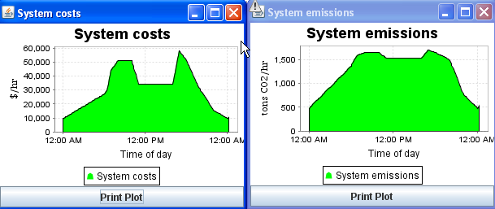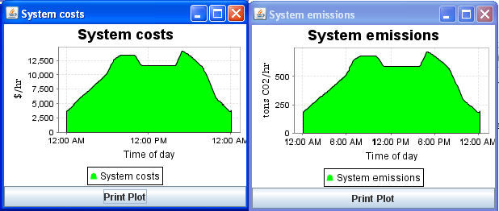Power system professionals use optimization tools such as linear programming to determine the optimal genera- tion dispatch on the system. This means that within the constraints of the transmission line capacities and the generator capabilities, the lowest cost generation is used to supply the load. In the applet the coal genera- tor costs less to operate than the natural gas generator so it provides power until it reaches its maximum or until its transmission line reaches its maximum capacity. Power from the wind farm has no fuel cost so when it is connected it is dispatched first. The coal generator and then the natural gas generator are dispatched next.
When the peak demand is 750 MW and the wind farm is not connected, only the coal generator is producing electricity.
Each of the scenarios in Lesson 5 demonstrates differ- ent costs and emissions based on the generation mix.
Consider how this type of simulation can help power professionals make decisions about how to supply elec-

tricity.
More Resources
When the peak demand is 2000 MW and the wind farm is not
connected, the coal generator produces the first 1500 MW of electricity and the natural gas is producing the rest.

- Energy Explained, from U.S. Energy Information Administration, has graphs, data, and scientific information about energy. www.eia.doe.gov/energyexplained

Wind and Storage Lesson 5
Use the applet at http://tcipg.mste.illinois.edu/applet/ws to consider costs and emissions as the communities grow and demand increased power. When the applet opens or the Reset Entire Simulation button is clicked, the peak community power demand is 750 MW. Click on the buttons for Plot system costs and Plot system emissions and watch the plots for at least 24 hours. (You may have to move the windows to see both.)
- What is the peak cost? What is this peak time?
- What are the peak emissions? At what time does the emissions peak occur?
- How does the emissions plot compare with the cost plot?

Move the slider at the bottom of the applet to increase the peak community power demand to 2000 MW and press the Reset Time button. Watch the plots for at least 24 hours.
- What is the peak cost? What is this peak time?
- What are the peak emissions? At what time does the emissions peak occur?
- How does the emissions plot compare with the cost plot?

Move the slider at the bottom of the applet to increase the peak community power demand to 3000 MW and press the Reset Time button. Watch the plots for at least 24 hours.
- What is the peak cost? What is this peak time?
- What are the peak emissions? At what time does this peak occur?
- How does the emissions plot compare with the cost plot?

- Explain the differences in these situations.

- Close the switch between substation 1 and substation 2 to connect the wind farm to the com- munities. How do the costs and emissions change as you change the peak community power de- mand?

Wind and Storage

Comments for Teachers
Wind farm production is determined by the number and

Lesson 6

capacity of the turbines and by the wind resource. When the ap- plet at http://tcipg.mste.illinois.edu/applet/ws opens or is reset, the Wind Farm Capacity is set at 195 MW. This means that under
Twin Groves II Wind Farm in McLean County, Illinois is the second phase of the Twin Groves project. There are 120 turbines and the capacity of each is 1.65 MW to make the capacity of this wind farm 198 MW. Horizon Wind Energy, the owner and operator, claims that these turbines produce enough power for 54,000 aver- age Illinois homes.
perfect wind conditions this wind farm could produce 195 MW of
power. The wind generation plot shows the actual production con- sidering variation in wind and the constraint of the transmission line between substations 1 and 2. In the early hours of the morning, there is less wind. The wind farm output is approximately 110 MW and all of that is going to the communities. Later in the day there is more wind so the maximum wind output could reach 195 MW, but because the transmission line between the wind farm and the com-
munities has a maximum capacity of 125 MW, the maximum wind-
generated power supplied to the communities is never more than 125 MW and any extra is curtailed.
If the utility wants to supply the communities with more wind gen- erated power it could build more turbines, but it also needs to con- sider increasing the capacity of the transmission line between sub- station 1 and substation 2.
Wind speed varies and demand for electricity is constantly changing. Power professionals collect and study data over time and know that there are predictable patterns. The wind output in the applet is based on a study done by the Illinois Institute of Technology for the City of Chicago and the demand from the communities in the applet follows patterns based on data collected by the Energy Information Administration. For this simulation the patterns in the applet are the same for every day.
More Resources
- Wind Energy Basics from the American Wind Energy Association - www.awea.org/faq/wwt_basics.html
- Horizon Wind Energy Wind Farms - www.horizonwind.com/projects/whatwevedone/
- Twin Groves Wind Farm Virtual Tour - www.youtube.com/watch?v=nL0EjOmuPwY&feature=mfu_in_order&list=UL

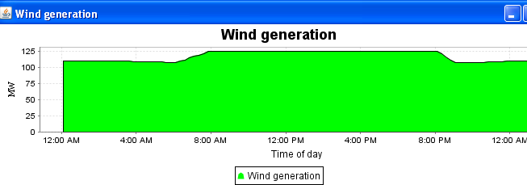

Wind and Storage Lesson 6
Use the applet at http://tcipg.mste.illinois.edu/applet/ws to explore the effects of adding wind power to the system. When the applet opens or the Reset Entire Simulation button is clicked, the peak community power demand is 750 MW. Close the switch between substation 1 and substation 2 to allow transmission of power from the wind farm to the communities. The arrows are orange because the line is at or near its capacity.
- Reset Entire Simulation, close the switch between substation 1 and substation 2, and watch the wind farm and the transmission line between substation 1 and substation 2 for a full 24 hour day. How much power does the wind farm generate? How much power flows between these substations?
Peak community power demand 750 MW
Approximate times | 4:00 AM | 8:00 AM | 12:00 noon | 5:00 PM | 10:00 PM
Wind farm
Production (MW)
Max. wind output availa-
ble (MW)
Wind output curtailed
(MW)
Power flowing from sub-
station 1 to 2
Fuel Cost ($/hr)
Emissions (tons/hr)

- Complete the chart to
help you analyze the
information.
- At what times during the day is the available wind output highest?

- Why is some wind output curtailed?

Notice the slider for Wind farm capacity. The wind farm’s capacity is 195 MW when the applet opens. This slider sets the maximum power the wind farm can produce under perfect wind conditions. The power utility could increase the wind farm capacity by building more turbines.
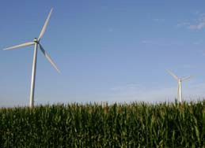
- What changes when you move this slider?

- How does the plot showing system costs change when wind is added to the system?

Wind and Storage

Comments for Teachers

Lesson 7

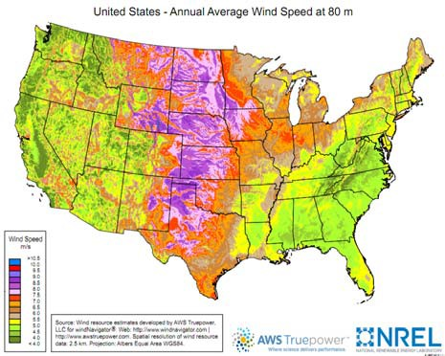
The three maps on this page compare wind resource, installed wind power and population density. Current wind installations are typically in regions with good wind, but also near population centers and in states with favora- ble policies for developing renewable energy sources.
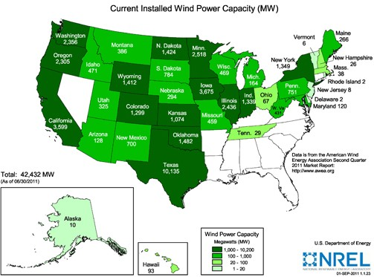
As of June 30, 2011, the U.S. had 42,432 MW of installed wind capacity. Whereas, at the end of 2000 this number was 2539 MW. This increase is the result of improving technologies and in- creasing public interest in clean, renewable, do- mestic energy sources. New turbines are taller and able to access wind resources in areas that were previously thought not to be sufficient for wind farms. At the end of 2000 only seventeen states had installed wind power capacity and there were only 61 MW installed east of the Mis- sissippi River. By the end of June, 2011, there were wind farms in 38 states.
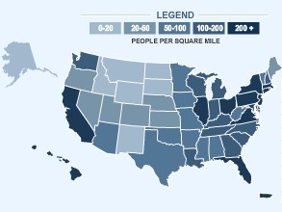
One goal of the U.S. Department of Energy is for wind to supply 20% of U.S. electricity by the year 2030. Reaching this goal is feasible, but in addition to increased turbine installations, it will require increased power grid infrastructure and reliable data resources that allow power systems professionals to accurately forecast wind energy potential at any time.
More Resources
- Wind Powering America
www.windpoweringamerica.gov/ 2010
- U.S. Department of Energy Wind Power Program http://www1.eere.energy.gov/wind/
- 2010 U.S. Census data 2010.census.gov/2010census/data/
- U.S. Energy Information Administration Energy in Brief - Wind Power http://www.eia.gov/energy_in_brief/wind_power.cfm

Wind and Storage Lesson 7
Use the applet at http://tcipg.mste.illinois.edu/applet/ws to investigate issues related to transmission and wind power. When the applet opens the Capacity of the transmission line from substation 1 to substation 2 is set at 125 MW and the Wind farm capacity is set at 195 MW. Connect substation 1 to substation 2. When the wind farm produces more than the transmission line can carry, the power is curtailed. The power utility needs to increase the transmission capacity if it wants to supply more wind power to its customers.
Wind power pro- fessionals look for these three things when they want to establish a wind farm:
- good wind
- a willing com- munity
- sufficient
transmission
  - Why might the utility want to supply more wind power to its customers?

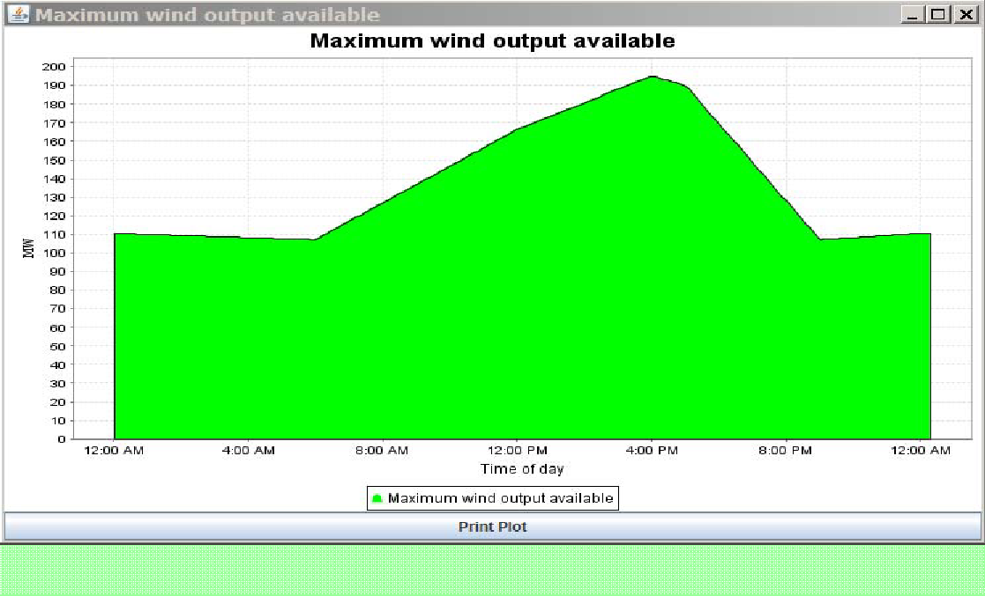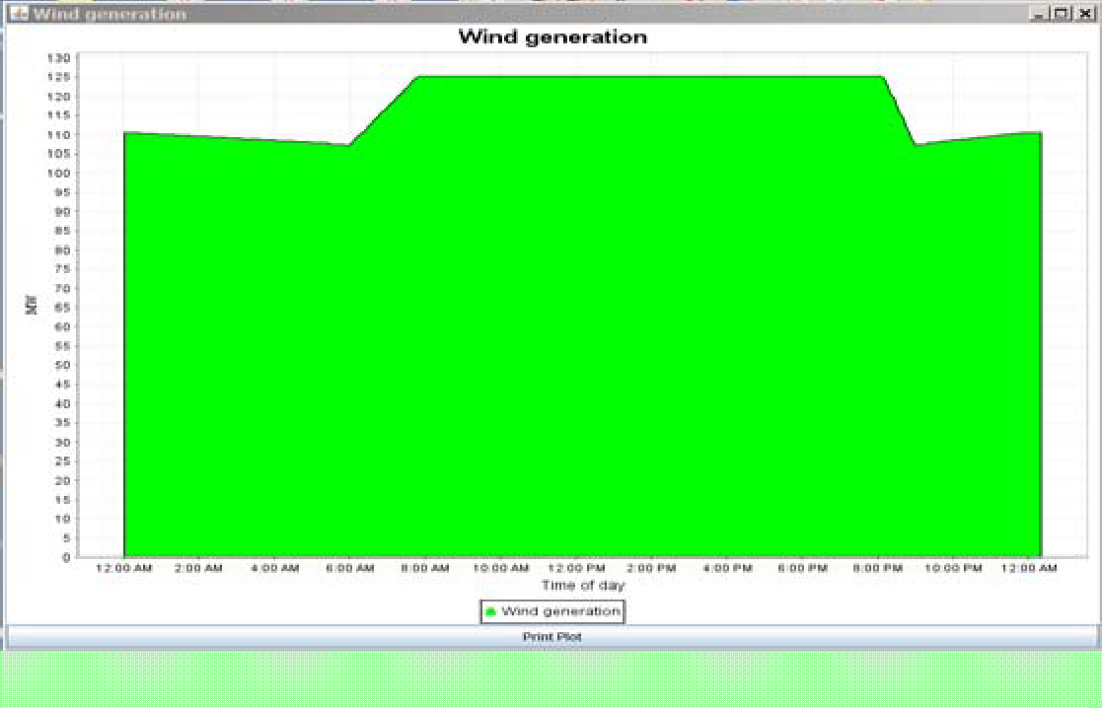Reset Entire Simulation and connect substations 1 and 2. Then choose Wind generation from the Plot generation menu, click Plot gen, and click Plot max- imum wind power available. Reset Time and watch these plots for 24 hours and then press Pause Time. You might have to move or adjust the plot windows so you can see both at one time.
The turbines in the wind farm could generate this maximum power if no wind is curtailed.
The turbines in the wind farm actually generate this amount of power. Why?
  - What do these two plots show?

  - Use the slider to increase the Ca- pacity of the transmission line from substation 1 to 2. Reset Time and watch these two plots again. What do you notice now?

  - What decisions might the power utility make based on this information? What could be done to make wind generation a larger portion of the power supplied to the communities?

Comments for
Wind and Storage

Lesson 8

Teachers
When the applet at http://tcipg.mste.illinois.edu/applet/ws opens, or is reset, the wind farm is capable of generating more power than the transmission line between substations 1 and 2 can carry.
The wind generation plot shows genera- tion of 125 MW between approximately 8:00 AM and 8:00 PM, but the maximum wind output available shows more wind power available during these times. The utility needs to consider whether to in- crease the transmission capacity to take advantage of all the available wind power.
In the 1930’s utilities began to connect to each other to provide back-up generation for each other.
These connections grew into the interconnected grid we have today.
The utility may also consider increasing
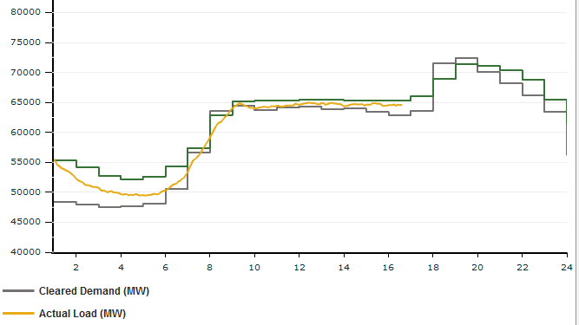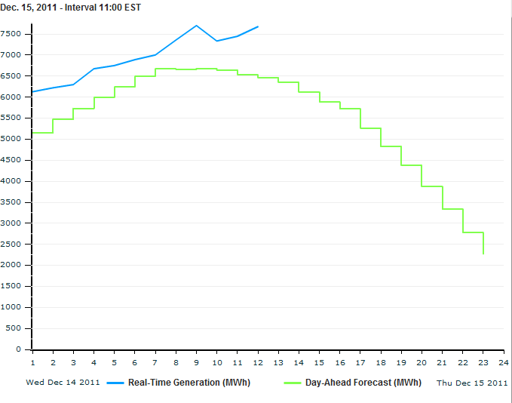the size of the wind farm, especially as it plans for in- creased demand from the communities.

The yellow line represents the actual power generated for all or part of 12 U.S states plus Manitobanon Dec. 15. The
MISO Real-Time Total Load
n

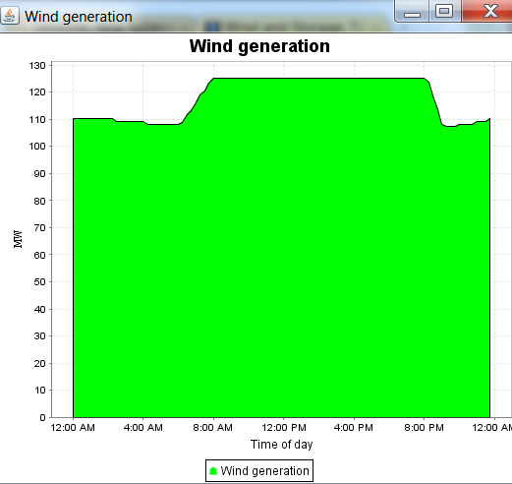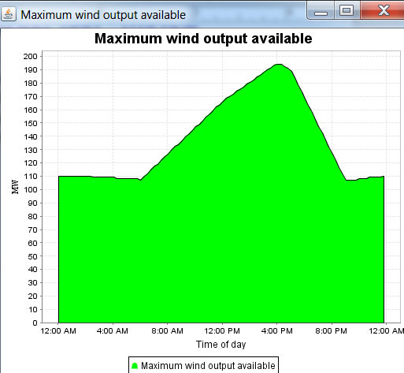
MISO Day Ahead Wind Forecast
 | The green line represents the Dec. 14 evening forecast f the following day. The blue line represents the actual wi generation on Dec. 15. | or d

More Resources
- U.S. Energy Information Administration Energy in Brief - Power Grid http://www.eia.doe.gov/energy_in_brief/power_grid.cfm
- TryEngineering Lesson Plan, Working with Wind Energy http://www.tryengineering.org/lesson_detail.php?lesson=60
- Real Time Data from the Midwest Independent Transmission System Operator (MISO) https://www.midwestiso.org/MarketsOperations/RealTimeMarketData/
- Congressional Research Service, Electric Power Transmission: Background and Policy Issues, April, 2009 http://fpc.state.gov/documents/organization/122949.pdf

Wind and Storage Lesson 8
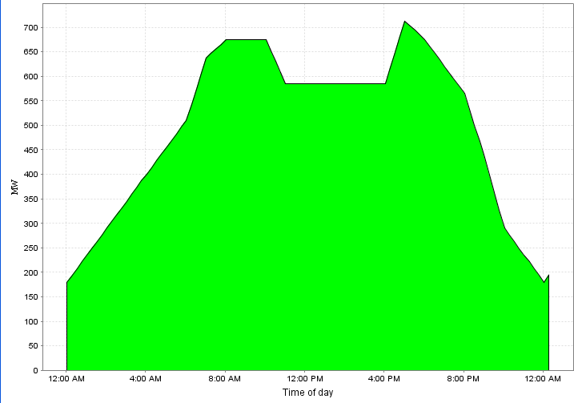Use the applet at http://tcipg.mste.illinois.edu/applet/ws to investigate issues related to increas- ing wind power generation. Consider how wind generation fluctuate s throughout the day and also how the demand from the communities varies. The utility would like to invest in more turbines and/or increased transmission capacity in order to develop a system that provides reliable elec- tricity and that includes 25—30 percent
wind power.
- This graph shows the total demand from

the three communities for one full 24-hour day when the peak is 750 MW. At what times is the demand high?
How much power is needed at these times?

Open the applet and close the switch be- tween substations 1 and 2. Click on the buttons to plot both coal generation and wind generation (You may have to move the windows to see both.) and Reset Time.
Pause Time after about 24 hours or when
The area of this graph is the total kWh’s of energy used by the system during one day.

Total community demand for one 24-hour period when peak demand is 750 MW

the clock on the applet gets near 12:00 AM again.
- How many MW of power are wind generated at 8:00 AM? Noon? 5:00 PM?
- How many MW are coal generated at 8:00 AM? Noon? 5:00 PM?
- What percentage of the total power needed is supplied by the wind at each of these times?
8:00 AM? Noon? 5:00 PM?
Increase the transmission capacity to 195 MW and plot wind and coal generation again.
- How many MW of power are wind generated at 8:00 AM? Noon? 5:00 PM?
- How many MW are coal generated at 8:00 AM? Noon? 5:00 PM?
5. What percentage of the total power needed is supplied by the wind at each of these times?
8:00 AM? Noon? 5:00 PM?

Explore these issues. Look at other times of the day. Increase the capacity of the wind farm and/or the capacity of the transmission line. Describe some options for the utility so it can meet its goal of 25 - 30% wind. The applet doesn’t allow you to consider the costs of building power plants or installing turbines or of increased transmission, but you should consider reliability, fuel costs, and emissions.

Comments for
Wind and Storage

Lesson 9

Teachers
When the Peak community power demand in the applet at http:// tcipg.mste.illinois.edu/applet/ws is higher than 1500, the coal genera- tor is not sufficient to provide all the power. The utility wants to keep

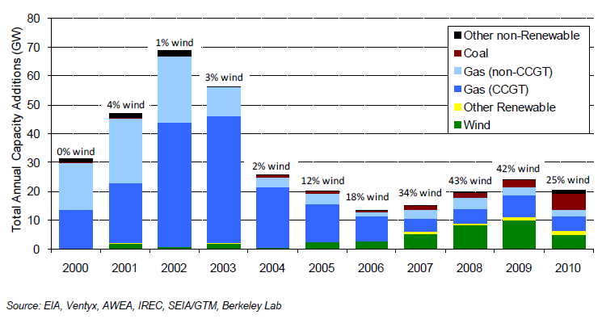both costs and emissions low. The available generation is dispatched so that the least costly is provided first.
Use the various choices students make for the wind farm and transmission capacities to help the utility balance costs, emissions, and reliability.
- Throughout most of 2011 Iowa created 20% of its total electricity from wind energy. How can the utility in the applet meet a 20% goal?
- What is the optimal size for the wind farm?
- What is the ideal capacity for the transmission line?
- Can the utility generate all the power the communities need using only the wind farm?.
- Can the utility use wind power to avoid using the natural gas generator?

This graph shows new sources of electricity ca- pacity additions in the U.S. New wind power projects were about 42% of the new electricity generation ca- pability added in 2009 and about 25% for 2010.

Quick Facts About Wind Power from the U.S. Department of Energy, Energy Efficiency and Renewable Energy http://www1.eere.energy.gov/wind/about.html
- The United States has more than 40,000 MW of installed wind power capacity.
- In 2010, the U.S. wind industry grew 15%, installing 5,115 MW of generating capacity—enough to power more than 1.2 million homes.
- Wind power represented 25% of all new U.S. electric generation capacity in 2010
- Commercial wind energy systems are currently installed in 38 states.
More Resources
- U.S. Department of Energy report includes grid operators insights into integrating wind energy into the grid http://energy.gov/articles/new-report-integrating-variable-wind-energy-grid
- U.S. Department of Energy report, 20% Wind Energy by 2030: Increasing Wind Energy’s Contribution to
U.S. Electricity Supply" http://www1.eere.energy.gov/wind/wind_energy_report.html

Wind and Storage Lesson 9
Use the applet at http://tcipg.mste.illinois.edu/applet/ws to explore generation and demand. Set the peak community power demand to 2250 MW and close the switch between substation 1 and substation 2 to allow transmission of power from the wind farm to the communities. Choose a capacity size for the wind farm and for the line between substations 1 and 2. Then complete the chart.
How did you choose the wind farm capacity?
Peak community power demand 2250 MW Substation 1 connected to substation 2 Wind farm capacity MW
Capacity of the transmission line between substations 1 and 2
Approximate times | 4:00 AM | 8:00 AM | 12:00 noon | 5:00 PM | 10:00 PM
Coal generation (MW)
Fuel Cost ($/hr)
Emissions (tons/hr)
Wind farm generation (MW)
Fuel Cost ($/hr)
Emissions (tons/hr)
Natural gas generation (MW)
Fuel Cost ($/hr)
Emissions (tons/hr)
Total generation
Total fuel costs ($/hr)
Total emissions (tons/hr)
Commercial demand (MW)
Residential demand (MW)
Industrial demand (MW)
Total demand
Percentage of wind generation
Percentage of coal generation
Percentage of natural gas gen- eration

Does the capacity of the line between sub- stations 1 and 2 need to be the same as the wind farm capacity?

Are demand and gener- ation always balanced?

When is peak demand?

When is the percent- age of wind generation greatest?
When is it least?

What are some ad- vantages of increasing the wind farm genera- tion?

What are some disad- vantages?

Wind and Storage

Comments for Teachers

Lesson 10

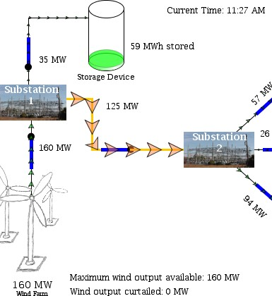You can use the applet at http://tcipg.mste.illinois.edu/applet/ws to investigate how the availability of large scale energy storage allows for the efficient use of intermittent
energy sources like wind and solar.
Starting at around 8am, the wind farm is transmission- constrained but the existence of storage allows the wind farm to put the energy that can’t go over the line into the storage. The storage device has a capacity limit of 100 MW and a stor- age limit of 1000 MWh. If the wind farm is generating more

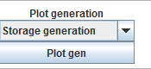
than the limits of the storage device and the transmission com- bined wind will be curtailed. Over the course of a day, you can see the storage absorb energy when the wind farm is generating above the 125 MW line constraint and deliver ener-
gy when the wind farm is generating below the 125
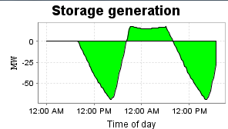
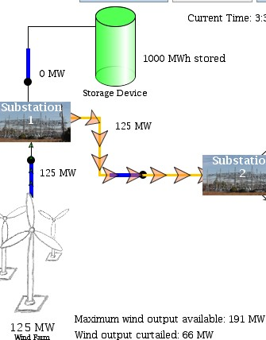MW line constraint. Plot the storage generation and view several days to see when the storage device is absorbing en- ergy and when it is providing energy. When
This line is at its 125 MW limit.

However, the wind is not yet curtailed because the storage is taking the excess energy.

the plot is below zero the storage device is storing energy and when it is above zero it is supplying en- ergy to the system.
You can use the applet to explore the effects of adding more wind power and/or increasing the capacity of the transmission line from substation 1 to 2. as peak community power demand increases.
The storage is full, so it can not take any more of the excess energy from the wind farm.

The wind is curtailed so

As renewable energy sources like wind and solar supply more power, the need for energy storage devices becomes more desirable. One early large scale storage project came online in Hawaii in March, 2011. The Kahuku Wind Power project includes a 30 MW wind farm with a 15
that the transmission line capacity is not exceeded.

MW battery system. In West Virginia the Laurel Mountain Wind Facility operates 61 1.6 MW wind
More Resources
- U.S. Department of Energy information about energy storage http://energy.gov/storage
- U.S. Department of Energy, Office of Electricity Delivery and Energy Reliability energy storage information http://energy.gov/oe/technology-development/energy-storage
- Three U.S. Department of Energy sponsored projects have been recognized for their progress in the development and implementation of energy storage systems.
http://energy.gov/articles/innovative-energy-storage-technologies-enabling-more-renewable-power
- Kahuku Wind Power http://www.firstwind.com/projects/kahuku-wind
- Laurel Mountain news http://www.earthtechling.com/2011/12/massive-battery-system-captures-the-wind/

turbines with 32 MW of lithium-ion batteries.

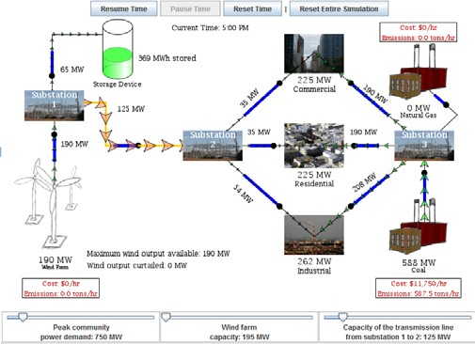
Wind and Storage Lesson 10
Use the applet at http://tcipg.mste.illinois.edu/ applet/ws to investigate how the availability of ener- gy storage could make more efficient use of wind power generation. Consider how wind generation var- ies throughout the day and also how the demand from the communities varies.
Set the peak community power demand to 750 MW and close the switch between substation 1 and sub- station 2 to allow transmission of power from the wind farm to the communities. Also, close the line between Substation 1 and the Storage Device. Use
the various plots to analyze the effects of available storage.
- How does the availability of storage affect the amount of curtailed wind output?

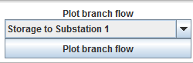
Reset Time and Plot branch flow for Storage to Substation 1. Allow time to run for at least six days.
- During which hours is power entering the storage device?

- During which hours is the storage device discharging power?
Power utilities currently must generate electricity just when the users need it, but researchers are experimenting with large scale energy storage systems Some hydroelectric power plants pump water uphill to a storage reservoir when demand is low and then allowing it to flow downhill through a turbine/generator when demand is higher Batteries are a familiar example of energy storage, but the batteries you use at home store a very small amount of energy. Newer larger batteries have been developed for use in electric vehicles, and systems of large batteries, like the one in the applet, are under development. Researchers are also investigating other forms of storage including compressed air storage and flywheel storage.

- How does the plot change after a few days? What does this suggest?

- Does the availability of storage prevent curtailment of the wind generation?
- The utility wants to be prepared for the peak community demand to increase to 1250 MW in the near future. It also wants to optimize wind power generation and keep CO₂ emissions below 1000 tons CO₂/hr. What is the ideal size for the trans- mission line from substation 1 to 2 if the wind farm capacity re- mains at 195 MW? How does the availability of storage affect the needed transmission line size?

Wind and Storage

Comments for Teachers
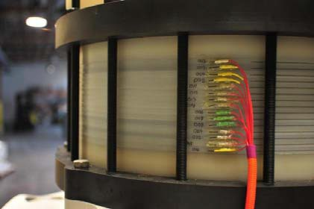Wind power and solar power are domestic energy sources that have the potential to de- crease dependence on fossil

Primus Power's energy cell stack - Photo Courtesy of Primus Power

Primus Power has developed a low-cost, distributed storage flow battery made of tanks filled with high energy density electrolytes that are pumped throughout the battery sys- tem. This flow battery can store renewable energy such as wind and solar power and then release that energy into the grid during peak load times. Since renewable energy is intermittent, the ability to store this electricity to balance grid power is becoming significantly more important as renewables become more prevalent in the U.S.
- U.S. Department of Energy, http://energy.gov/articles/primus- power-s-flow-battery-powered-11-million-private-investment
fuels and lower carbon dioxide emissions. Yet, large in- creases in these variable generation sources create new challenges for grid operators. Systems operators have historically dispatched generation in response to con- stantly changing consumer demands. With increasing generation from intermittent sources like wind and solar electric power professionals are developing strategies for responding to changing production as well. New ad- vances in energy storage systems allow dispatchers to better use the energy produced by these renewable re- sources. Better tools for forecasting wind and solar gen- eration and consumer demand, together with real-time generation and load data also help system operators make the most efficient use of the available
 |  | PJM Interconnection Wind Power Graph
 |  | 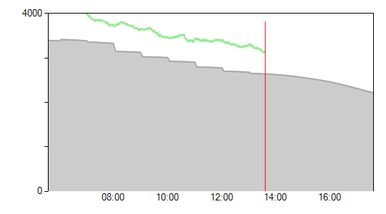
More Resources
 |  | last updated 1:30 PM EST | Current Wind Generation 3140 MW Today’s Wind Forecast 2645 MW
- Midwest ISO’s Wind Integration
https://www.midwestiso.org/WhatWeDo/StrategicInitiatives/Pages/WindIntegration.aspx
- PJM’s Renewable Energy Dashboard http://www.pjm.com/about-pjm/renewable-dashboard.aspx
- California ISO’s Renewables and Demand Response Integration http://www.caiso.com/informed/Pages/RenewablesDemandResponseIntegration/default.aspx
- Duke Energy partners with Xtreme Power to combine battery storage and wind power http://gigaom.com/cleantech/a-mega-wind-farm-needs-lots-of-batteries/
- Energy Storage - MW vs. MWh http://www.xtremepower.com/about-energy-storage/mw-vs-mwh.php
- Compressed air storage http://cleantechnica.com/2009/11/20/storing-renewable-energy-in-boxes-of-air/
- Hydroelectric pumped storage http://ga.water.usgs.gov/edu/hyhowworks.html
- National Renewable Energy Laboratory http://www.nrel.gov/wind/systemsintegration/energy_storage.html

energy resources.
The plots in the applet at http:// tcipg.mste.illinois.edu/applet/ws show actual data from representative days. Electricity systems operators use tools that look much the same as these plots, but rely on up-to-date real time and day ahead and data.

Lesson 11

Wind and Storage Lesson 11
Use the applet at http://tcipg.mste.illinois.edu/applet/ws to investigate the integration of wind power generation and energy storage as the demand for electricity increases. The utility’s coal and natural gas generators may be unable to supply the communities if the demand becomes too great. Without closing the switch between substations 1 and 2 increase the peak community de- mand to 3250 MW and reset the time. Watch the simulation run.
- Beginning at 12:00 AM (midnight) the coal generator is supplying enough power for all the com- munities. At what time does the natural gas generator also begin to supply power?
- What happens during the late afternoon peak time? Why?

- Close the switch between substations 1 and 2. Does this solve the problem?
- Use the plots for system costs and system emissions to compare these scenarios. Keep the capacity of the transmission line between substaions 1 and 2 at 125 MW.
  - Peak demand 3250 MW with only coal and natural gas generation
  - Peak demand 3250 MW with coal, natural gas and wind generation with capacity 195 MW
  - Peak demand 3250 MW with coal, natural gas and wind generation with capacity 195 MW and available storage.

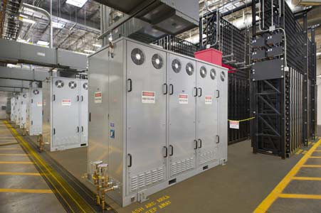
- It is predicted that the total peak community demand will increase to 3750 MW by the year 2020. The utility plans to supply this demand with at least 20% wind generated power. Use the applet to determine how the utility will meet these goals. The utility wants to keep costs and emissions both low, and does not want to increase fossil fuel generation. How large should the wind farm become? Should transmis-
sion capacity between substations 1 and 2 be increased? How much? Is the availability of storage desirable? Write a proposal describing how you think the utility should prepare for 2020.

Xtreme Power's Dynamic Power Resource at First Wind's Kahu- ku Wind project on Oahu. (Photo: Business Wire) See a video about energy storage here http://www.xtremepower.com/about- energy-storage/why-storage.php

TCIPG is funded by: The Department of Energy
The Department of Homeland Security http://tcipg.org
TCIPG Educational Development is a joint project of the Office for Mathematics, Science and Technology and Coordinated Sciences Laboratory at the University of Illinois.
These materials were developed by Judy Rocke, Jana Sebestik and Zeb Tate.
tcipg.mste.illinois.edu/

