Electricity and Time-of-Use Pricing

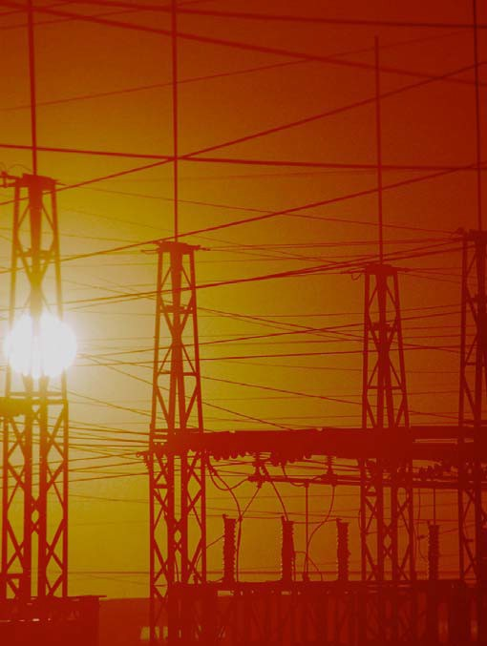

TCIPG Educational Development
TCIPG: Trustworthy Cyber Infrastructure for the Power Grid

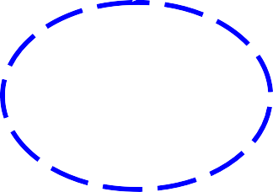Electricity and Time-of-Use Pricing

Comments for Teachers
Lesson 1
The applet at tcipg.mste.illinois.edu/applet/tou is an extension of the Power and Energy in the Home applet. It allows users to explore
Encourage students to explore the applet. Then use the lessons on the student pages to guide their investigations.
some proposed changes in the ways utilities may charge
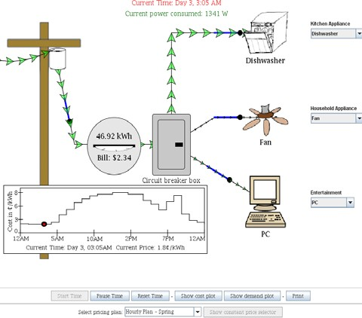
their customers for electricity. New technologies (smart meters are one example) are allowing consumers
to make choices about their
electricity use based on better information. Many utilities are
implementing plans that encourage their customers to use less electricity during times when demand is typically high. Some plans, like the one implemented in Ontario, divide the day into two or three periods and assign prices for each period. Other plans assign a different cost for each hour of the day.
Plans like these are being offered by various utilities as our electrical system begins to transition to a more
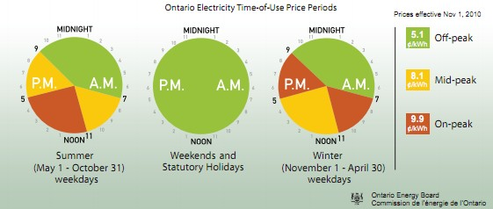
modern, smarter grid, using recent developments in research and technology. These technologies and accompanying changes characterize the transformation to the smart grid. They are designed to make the grid more reliable, secure, economical,
safer, and environmentally friendly. Part of this vision of a smarter grid includes consumer participation. With information about variations in electricity supply and demand, consumers will be able to adjust their electricity use in ways that lower costs, increase reliability, and decrease environmental impacts. New smart
meters that allow two-way communication between the consumer and the utility and that measure energy use in hourly intervals are being installed in many regions throughout the U.S. and Canada. These meters, together with other technologies that allow consumers to track their energy use online or remotely control energy-using appliances, are critical to making the electrical grid safer, greener, more economical,
more efficient, and more reliable.
More Resources
- U.S. Department of Energy modernizes the electrical grid. oe.energy.gov/smartgrid.htm
- Power Smart Pricing is an hourly pricing program from Ameren Illinois Utilities. Consumer participation is voluntary. powersmartpricing.org/
- Soon all of Ontario will participate in time of use pricing. Learn more ieso.ca/house/torontohydro/

Electricity and Time-of-Use Pricing Lesson 1
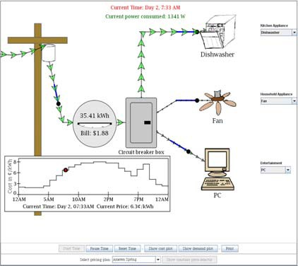
Use the applet at tcipg.mste.illinois.edu/applet/tou to explore time-of-use pricing options for purchasing electricity. Learn how these plans may save you money and help make the electricity delivery system more reliable and more environmentally friendly.
When the applet opens the pricing option is Hourly Plan-Spring, and the dishwasher, fan, and PC are using electricity. You can see the energy used and the bill on the meter, and you can see the time of day and current price per kWh on the graph under the meter.
Watch the red dot travel along the graph.
When the total electricity demanded by all consumer communities is low, utilities can produce enough to meet the demand using less expensive generation sources. But, when demand for electricity is high (typically weekday, late afternoons and early evenings, especially in summer), additional more expensive generation sources are needed and the cost rises. Until recently electricity providers charged their customers a rate that reflected an average of their costs, but now newer and more advanced meters allow utilities to determine their customer’s usage and also the time of day of that usage.
Many electric utilities in the U.S. and Canada are now offering their customers time-of-use or real time pricing options. These pricing plans reflect the actual cost of electricity for the utility. Customers who choose one of these plans may be able to lower their bills by consciously shifting some of their electricity use to times when demand for electricity (and price) is typically lower.
- At what times of day is the price lowest?

- How low is it?
- At what times of day is it highest?

- How high is it?
- How are families and businesses typically using electricity dur- ing these times?

- Change the pricing plan to Hourly Plan-Winter. What do you notice?

- Describe how this pricing is different from Hourly Plan-Spring
and tell why you think this is.

Electricity and Time-of-Use Pricing

Comments for Teachers
Lesson 2
Power needed by residential, industrial, and commercial consumers is not constant. The needs vary daily and seasonally, but in predictable patterns. During times when many consumers are using large amounts of electricity all at the same time (times of peak load) the power grid is under the most stress, and because more energy is needed, the cost of producing that en- ergy is increased during those times. Many utilities are piloting pricing plans that encourage consumers to conserve energy and to shift some of their electricity usage to off-peak times.
The demand for energy is expected to double by 2050. Meeting that demand will require a large investment in infrastructure for the power grid. This investment includes building new generators, transmission lines, substations, and updating and replacing older structures. “In the United States, the average generating station was built in the 1960’s using even older technology.
Today, the average age of a substation transformer is 42 years, two years more than their expected life span.” (The Smart Grid, p. 18.) These updates and improvements will be costly and require increases in consumers’ bills. However, without these improvements, the future energy needs could not be met. One way to postpone or eliminate some of the cost to improve the infrastructure is to reduce the energy we currently use, and put each kWh generat- ed to better use by increasing efficiency and reducing losses.
Two of the example plans in the applet divide the day into off-peak (4.2¢ per kWh), mid-peak (7.6¢ per kWh), and on-peak (9.1¢ per kWh), pricing periods. These are modeled on plans currently offered in Ontario. Several
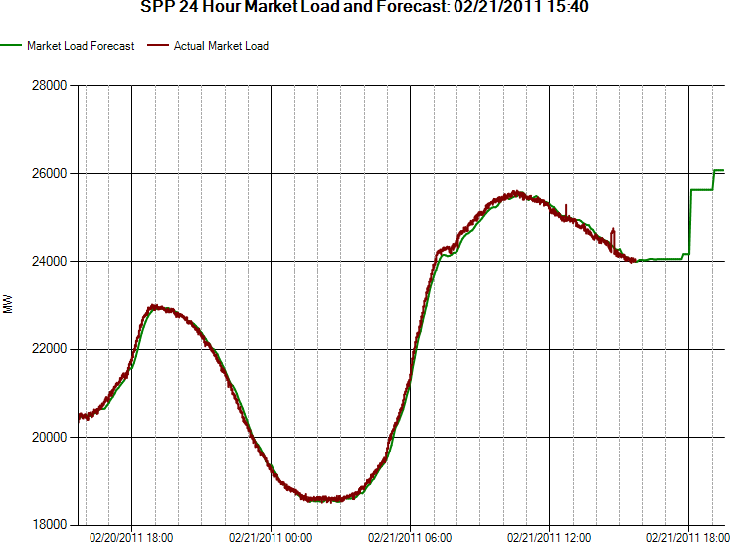
U.S. utilities are offering time-of- use pricing, with
either two or three
levels of pricing, to some or all of their customers. Typi- cally, these plans charge off-peak rates on weekends and holidays.
The applet also of- fers hourly pricing plans for example days from each of the seasons. Utili-
Southwest Power Pool provides power services to utilities in nine states
ties in Illinois, New Jersey, Maryland, Delaware, Pennsylvania, and Califor- nia offer hourly plans to their customers. Weekend pricing is also typically lower with this type of plan. You can more find information about real time and day ahead pricing from one of the ten Independent System Operators or Regional Transmission Organizations (ISO/RTO’s) in North America.
More Resources
- Faces of the Recovery Act: The Impact of Smart Grid youtube.com/user/USdepartmentofenergy#p/search/2/9RJiElIhBz4
- Map of (ISO/RTOs) in North America http://sustainableferc.org/iso-rto-operating-regions/
- Southwest Power Pool spp.org/section.asp?pageID=1
- A Smart Grid for Intelligent Energy Use https://www.youtube.com/watch?v=YrcqA_cqRD8

Electricity and Time-of-Use Pricing Lesson 2
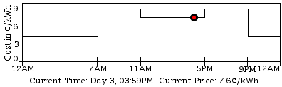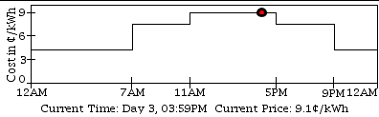
The applet at tcipg.mste.illinois.edu/applet/tou allows you to explore several examples of time-of-use pricing plans.
Summer
- One type divides the day into two or three periods and
assigns prices for each period. This option has different pricing for summer and for winter. How are the summer and winter plans alike and how are they different?
Winter
- The hours when the price is highest are when electricity use tends to be highest. These are called on-peak times When are on-peak times during summer?
- Why do you think the on-peak times in winter are not the same as those in summer?

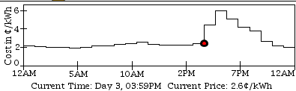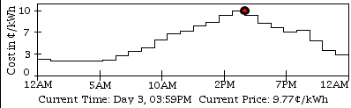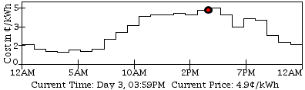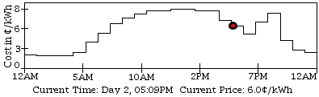Hourly plan-summer

Hourly plan-fall

Hourly plan-winter

Hourly Plan-spring
The hourly plans assign a cost for each hour of the day, and pric- ing varies every day. The applet shows example days for the four seasons of the year.
- What do you notice about the range of costs on the vertical axes for these four graphs?

- What are the on-peak times in summer? In winter?

- How does the summer on-peak price compare with the on-peak price in winter?

- How does the summer on-peak time compare with the on
-peak time in winter?

- Which season offers the lowest electricity prices for the greatest number of hours?
Why do you think this is so?

Electricity and Time-of-Use Pricing

Comments for Teachers
Lesson 3

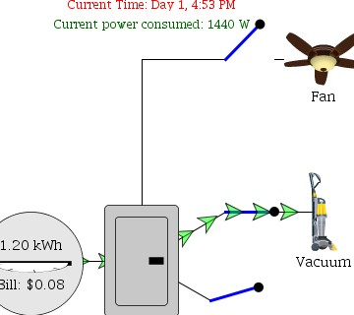
In the configuration shown to the left, only the switch to the vacuum is closed so the Current power consumed tells us that the vacuum is demanding 1440 watts of power. Current Time is Day 1, 4:53 PM, so the meter tells us that 1.20kWh (1200 watt hours) of energy costing $0.08 have been used since 4:00 PM.
Paying an energy bill has often been passive. A bill arrives, and it is paid. Many people do not feel they have any say or choice in the matter. People often feel helpless when it comes to making decisions about the energy they use in their homes. How could a family take control of their energy costs? How could they make a difference to the entire grid? The combined efforts of normal residential customers can significantly reduce the need for new generators and transmission lines and, as a result, help control the cost of electricity.
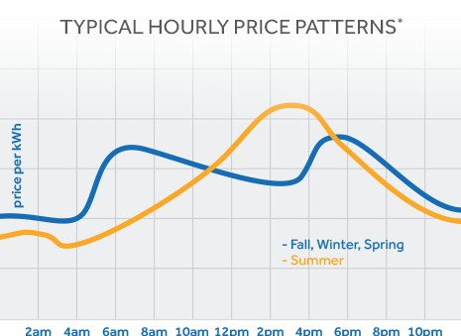Many retail electricity providers in the U.S. are installing advanced meter- ing systems that can provide information to consumers about how much electricity they use, when they use it, and how much it costs. Smart me- ters can measure energy use
and the time at which it is used. When this infor- mation is provided to con-
sumers they have an incentive to use less electricity and to shift some usage to off-peak time.
Power Smart Pricing, available to customers of Ameren Illi- nois, and the ComEd’s Hourly Pricing Rate Option are two examples of hourly pricing programs.
Both use hourly prices that are set the day before based on the prices in the Midwest Independent System Operator
(MISO) electricity market. The day-ahead prices are the

actual prices used to calculate the bill. These programs of- fer a variety of bill comparison tools and energy saving tips.

More Resources
- Power Smart Pricing powersmartpricing.org/
Learn more about this graph at https://www.powersmartpricing.org/ how-it-works/

- ComEd’s Hourly Pricing Rate Option https://www.comed.com/customer-service/rates-pricing/real-time-pricing/ Pages/program-information.aspx
- The Smart Grid: An Introduction oe.energy.gov/DocumentsandMedia/DOE_SG_Book_Single_Pages(1).pdf
- Midwest Independent System Operator midwestiso.org
- Energy Consumers Respond to the Smart Grid
energy.gov/articles/two-new-studies-show-how-energy-consumers-respond-smart-grid-technology

Electricity and Time-of-Use Pricing Lesson 3
When the applet at tcipg.mste.illinois.edu/applet/tou starts, notice the current power consumed shown at the top of the page. Arrange the blue switches so power is reaching only one appliance at a time.
- Complete the Power consumed column in this chart.
Items | Power  consumed (W) | Rank from greatest to least power consumed | Does this need to be used during peak load times? (yes or  no)
Dishwasher
EnergyStar (E-Star) Dishwasher
Fridge
EnergyStar (E-Star) Fridge
Microwave
Toaster
Incandescent Light
Fluorescent Light Tube
Compact Fluorescent (CFL)
Fan
E-Star Fan
Room A/C
EnergyStar (E-Star) Room A/C
Hot Water Heater
Iron
Hair Dryer
Vacuum
Clothes Washer
EnergyStar (E-Star) Washer
PC
XBOX 360
Playstation 3
Wii
40” LCD TV
42” Plasma TV

- Rank the items from the most power to the least power consumed in the second column.
- Some of these items could be used in only off-peak times. Go over the list and decide if an item could wait to be used during an off
-peak time and complete the last column.
- How did you decide? What did you use for your criteria?

- How would delaying the use of some items to off-peak times help the power grid?

- How would delaying the use of some items to off-peak times help with your electric bills?

10% of all generation assets and 25% of distribution infrastructure are required less than 400 hours per year, roughly 5% of the time. ‐ The Smart Grid: An Introduction, 2008

Electricity and Time-of-Use Pricing

Comments for Teachers
Lesson 4

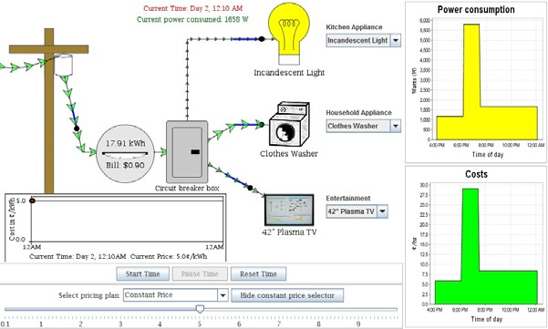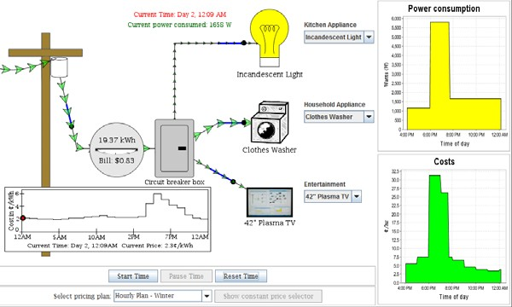
Because electricity traditionally has been charged at a con- stant rate, most consumers have not been concerned with the time of day of their electricity usage. In this activity students look at a series of electricity usages during late afternoon and evening hours. In these two scenarios only the pricing plans are different. (Small variations in energy use may occur be- cause of differences in when the applet user starts and stops the clock.) In the first scenario the rate paid for electricity is a constant 5 cents per kWh and energy cost is determined solely by demand. The graphs for demand and cost look alike. In the second scenario the rate varies with time of day (between
  - and 6.4 cents) and the energy cost is determined by both time of day and demand. The graph shows
During times when many consumers are using large amounts of electricity all at the same time (times of peak load) the power grid is under the most stress. Because more energy is needed, the cost of producing that energy is increased during those times. Many utilities operate gen- erators on standby that are used only during heat waves that occur a few times each summer. The rest of the year these generators are idle. Reducing the amount of energy needed during these peak load times will make it possible for the power grid to meet electricity needs with- out building more of these costly peak load gen- erators. If energy usage was more constant
and did not peak, the current infrastructure could handle energy needs for several more years, and so reduce or postpone new construc- tion costs. Every time members of a family re- duce their energy needs, especially during peak load times, they are helping not only to save money on their next electric bill, but they are also making it possible for existing generators to meet demands without the need to build costly, new generators.
that cost is highest when demand is high during a time when the rate is also high.
- U.S. Department of Energy Smart Grid Primer www.oe.energy.gov/DocumentsandMedia/DOE_SG_Book_Single_Pages(1).pdf
- Oklahoma Gas and Electric Smart Hours program https://oge.com/wps/portal/oge/save-energy/smarthours
- Shopping for Home Appliances
http://www.consumer.ftc.gov/articles/0072-shopping-home-appliances-use-energyguide-label
More Resources

Electricity and Time-of-Use Pricing Lesson 4

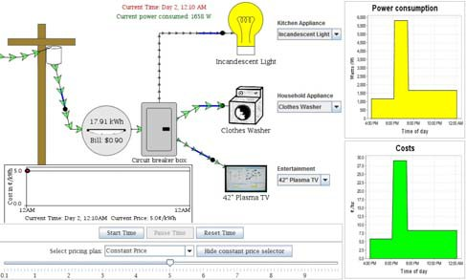
Traditionally, many consumers have been charged a constant rate for their electricity supply. Depending on the utility, there may have been summer and winter rates, but the price for one kilowatt hour of ener- gy has often been the same for every hour of the month. Even though the price to consumers has been a constant rate, the cost to the utility has varied throughout each day. Smart meters that are able to transmit data about energy usage in real time are now
being installed by several utilities. By using time- sensitive pricing plans these new technologies allow con- sumers to purchase electricity at rates that are closer to the actual costs paid by the utility for the energy they supply to their customers.
Use the applet at tcipg.mste.illinois.edu/applet/tou to investigate some of these plans.

    - Pause Time and select the constant price plan and set the rate to 5¢ per kWh.
The demand for electricity is expected to double by 2050. Meeting that demand will require a large investment in infrastructure for the power grid.
One way to postpone or eliminate some of the costs to improve and expand the infrastructure is to reduce the energy we currently use, and also to better use the energy we now have available. Smart meters and time-of-use pricing are an option that gives a family information and control of their electricity costs, while at the same time making a difference that potentially benefits the entire electrical system.
      - Choose the E-star fridge, the E-star Room AC, and the Plasma TV.
Reset the time so it’s 4:00 PM and start time.
      - Pause time at 6:00 PM and change the appliances to the dishwasher, hot water heater, and the PC.
      - Resume time until 7:30 PM. Then choose the incandescent light, clothes washer, and the Plasma TV.
      - Resume time until 12:00 AM. Read the meter and record the kWh used and the bill.
      - Look at the cost plot and the demand plot. How does cost relate to demand?

    - Pause Time and select the Hourly—Winter price plan. Follow steps a.—d. above.
Look at the cost plot and the demand plot. How does cost relate to demand?

    - How could an hourly pricing plan help save money for the consumer?

    - How could an hourly pricing plan result in higher bills for the consumer?

Electricity and Time-of-Use Pricing

Comments for Teachers
Lesson 5
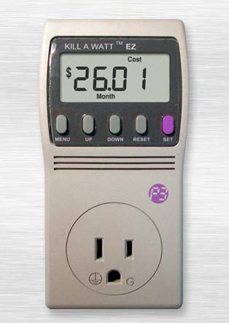The example appliances in the applet and most of the appliances in your home are either off or on, but a few of the appliances in your home are more compli- cated. Any appliance with a clock is demanding some elec-
Your electricity bill prob- ably has three major bill- ing categories; electric supply, delivery service, and taxes.
The electric supply charge is the charge shown in the applet and is the charge that varies with the time of day.
The delivery charge in- cludes the charge for the wires that carry electric- ity and the meter and transformer pole or box near the house. These charges vary greatly from to region, and may be 30% - 50% of your total electricity bill.
The two charges combine to become the retail price. In August 2015 the average retail price for residential electricity in the U.S. was 12.93 cents per kWh.
tricity whenever it is plugged in. A frost-free refrigera- tor, for example, may need electricity to power one or more fans, a compressor, an interior light, an icemaker and a heater. Each of these components may be “on” at vari- ous times. The model, size, and age of a refrigerator, its contents, location, and how often the door is open all con- tribute to the energy use of a refrigerator.
One way to find out how an appliance uses energy is to

take measurements using a home energy monitor like a Kill A Watt or Watts up? power meter. Plug the meter into a standard wall outlet and plug the appliance into the
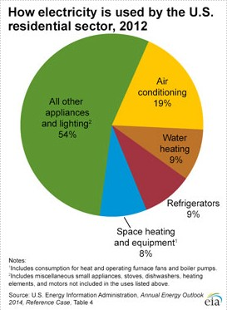meter. Monitor the watt read- ing to find the
Many libraries throughout the
U.S. offer Kill A Watt meters for checkout.

power needed at a particular instant and view the kilowatt hours used over an elapsed period of time to find the energy used during that time pe- riod.
A refrigerator, air-conditioner or electric hot water heater demands a lot of power and is also used for ex- tended periods of time so these are among the largest users of electrici- ty in most homes. Because homes have so many lights, total lighting is also a large portion of household electricity use.
More Resources
- Information for using the Kill A Watt http://www.green-energy-efficient-homes.com/kill-a-watt.html
- Watts Up power meter https://www.wattsupmeters.com/secure/uses.php?pn=6
- How refrigerators work http://home.howstuffworks.com/refrigerator.htm
- U.S. Energy Information Administration information about electricity http://www.eia.gov/electricity/
- eMission is a Facebook game from EPA and dosomething.org designed to encourage environmental actions and to increase energy efficiency awareness http://www.energystar.gov/index.cfm?c=globalwarming.emission

Electricy and Time-of-Use Pricing Lesson 5

Use the applet at http://tcipg.mste.illinois.edu/applet/tou to further explore time-sensitive pricing op- tions for purchasing electricity.
- Choose the three items in the applet that use the most power. Which items did you choose?
- Select the Three-tier plan - Summer pricing. Reset the time and show the cost plot. Watch the current time in red at the top of the page. Press pause time after 24 hours. (Notice that when you reset the time the day begins at 4:00 PM.) Reset the time and switch the pricing plan to Three-tier plan - Winter pricing, click on the start time and again watch the plot for 24 hours. Continue reset- ting time, changing the price plan, and starting time every 24 hours until you have a plot that shows the daily prices for each of the seven pricing plans.
- Which plan has the most variations in pricing?
- During which season is the price for electricity lowest? Why do you think this is so?
4. Again turn on the three items that use the most power. Complete the chart.

Price plan | Approximate Cost per day | Average cost per hour | Average cost per month
Three-tier plan - Summer
Three-tier plan - Winter
Hourly Plan - Summer
Hourly Plan - Fall
Hourly Plan - Winter
Hourly Plan - Spring
Constant pricing set at $.05 /kWh
- In this situation the constant pricing plan is not the most expensive plan. List some advantages and also disadvantages of this pricing plan.
- Most of the items in the applet would not be used for a full 24 hours. How long does the dishwasher run? Explore how much money could be saved by using the dishwasher for 90 minustes once a day af- ter 9:00 PM rather than starting it at 6:00 PM.
According to the US EPA, lighting accounts for roughly 11 % (down from 20% only a few years ago) of household electric bills. Federal policy is fostering the development of more energy efficient lighting.

- Imagine you are a consumer and are interested in creating a schedule tell- ing appliances in this applet when to run to help save money and conserve power during peak loads. Keep in mind that some appliances may need to run constantly and others only need to be used a short time during the day. Also some are only used seasonally. What are some of the difficul- ties you would have trying to create and implement this type of schedule in
your home?

Electricity and Time-of-Use Pricing

Comments for Teachers
Lesson 6

Smart grid technologies that include smart meters are bringing pricing op- tions to consumers. Utilities, energy industries, and others interested in en-
ergy policy are making pricing information and tools available to consumers. The applet at tcipg.mste.illinois.edu/applet/tou allows the user to choose pricing plans similar to those portrayed by the tools on this page. Explore the live data available via the internet and compare it to the applet.
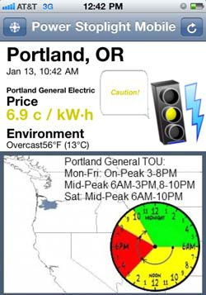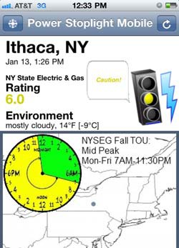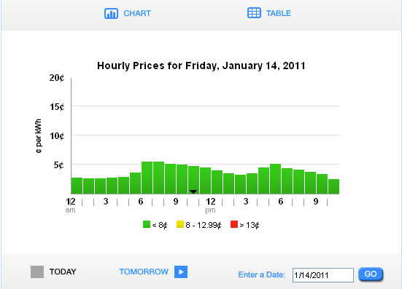Businesses, schools and homes that have installed wind turbines or solar panels may have real time moni- toring systems like those at Metamora Township High School.
. The Solar Schools project http://solarschools.org/ lists schools in several states with links to their solar data monitoring.

Power Stoplight shows current environmen- tal data and energy pricing in- formation for regions in all parts of North America.
powerstoplight.com
Ameren’s Power Smart Pricing customers can access hourly prices for the current day or any day since March 1, 2007
www.powersmartpricing.org/prices/
More Resources
Ontario Energy Board customers with smart meters purchase elec- tricity at three differ- ent time of use rates. Information about total Ontario demand is also available.
oeb.gov.on.ca/OEB/Consumers
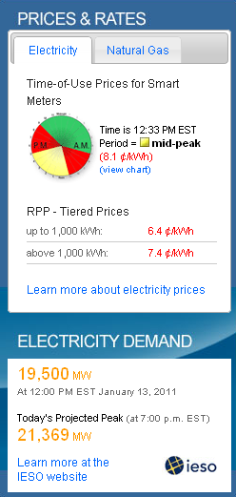

- The Economist, Tech.view on residential energy-monitoring systems economist.com/node/15585504?story_id=15585504
- Elevate Energy www.elevateenergy.org/

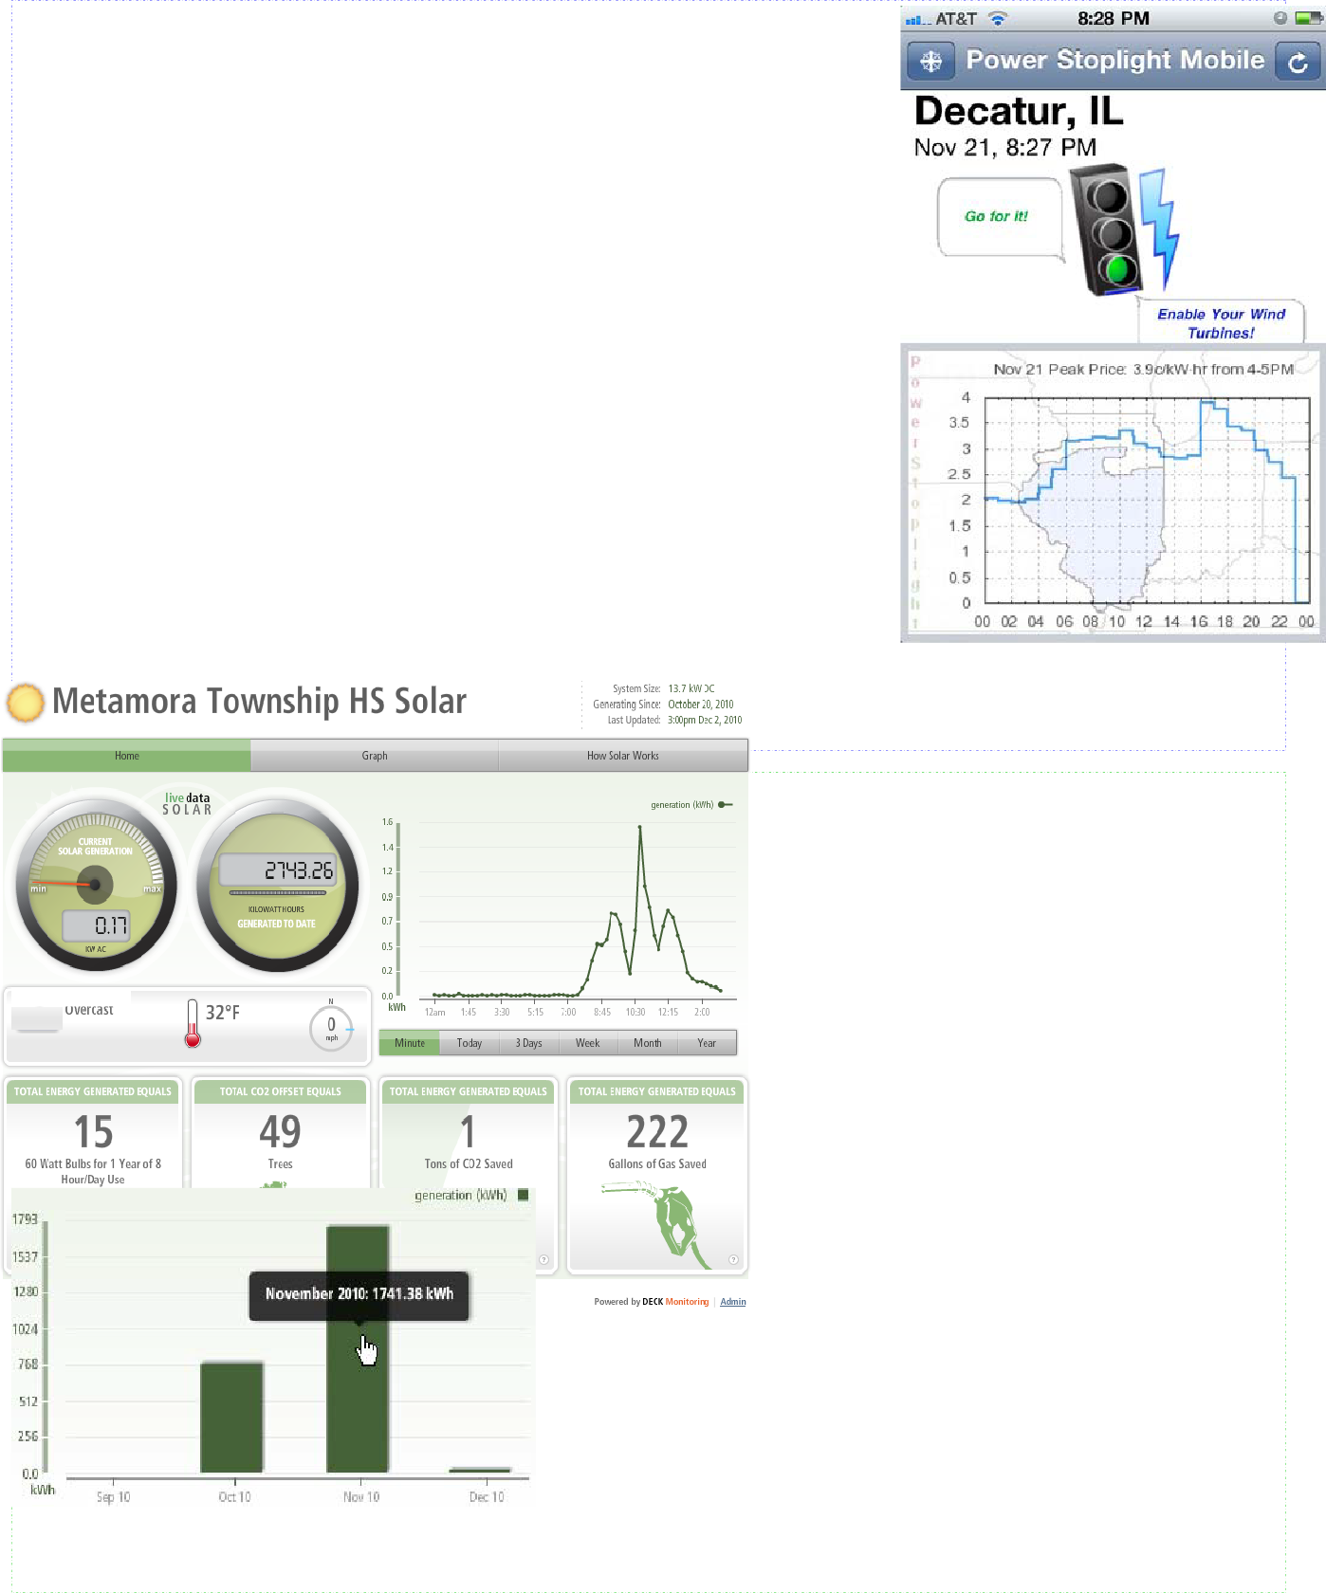
Electricity and Time-of-Use Pricing Lesson 6

As utilities institute time–of-use pricing plans, consumers need more information to make informed decisions about the energy they use in their homes. Power Stoplight is a smart phone app that shows current price, environmental infor- mation and smart grid data for regions throughout North America.
- The Power Stoplight screen at the right shows Nov. 21, 2011 data for areas of Illinois served by Ameren. Ameren customers who chose the Power Smart Pricing option paid 2.5 cents per kWh for the electricity they were using at 8:27 PM. What was the price of electricity at 10:00 AM on that day?
- What was the peak price that day? At what time?
- What was the lowest price that day? At what time?
- How might access to this kind of data help families plan their electricity use?
- How is the information from Power Stoplight like the applet at tcipg.mste.illinois.edu/applet/tou?

In October, 2010, Metamora Township High School in central Illinois mths.metamora.k12.il.us/ installed 64 solar pan- els in 8 arrays near the school track and football field. The live data feed gives information about the generation, the weather, and the envi- ronmental offsets.
Was it sunny or cloudy on Dec. 2, 2010?

At what time during that day were the solar panels producing the most power?
The school estimates that the solar panels will produce 8% - 10% of the school’s energy needs.
If the school used 19,150 kWh of electricity during November, what percentage was supplied by the solar panels?

If the school pays 10 cents per kWh for electricity and participates in net metering, by how much did the solar panels reduce the electricity bill?

Electricity and Time-of-Use Pricing

Comments for Teachers
Lesson 7
Manufacturers are developing “smart appliances” that can help the consumer reduce usage during times when electricity prices are high. Some of these will have a programmable feature that instructs the appliance to go into an
energy saving mode during times of peak load. Others may communicate directly with the power grid and cycle off for a short time period when the grid is stressed.
Studies show that consumers are willing to help control energy costs, but most are looking for a “set-it-and-forget-it” type approach when it comes to managing the energy needs in their homes. Using a device like a Kill A Watt is an interesting way to learn about energy usage, but most consumers do not want to spend hours a day monitoring their needs and deciding when it is the best time to use energy. Us- ing a home energy management system or energy information display is one way for consumers to get in- formation and manage their energy use. Several companies are introducing these systems. Examples in- clude energy hub, GE WiFi Connect, and LG THINQ. Cisco, Google and Apple are also all developing energy management systems. Consumers who already use programmable thermostats or remotely schedule DVR’s may be ready to extend similar technologies to other appliances.
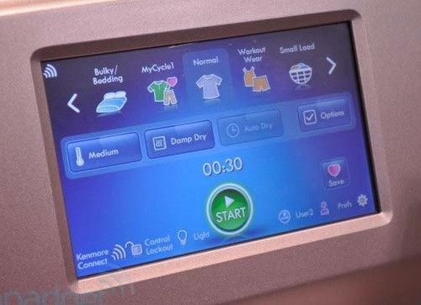
Several manufactures are beginning to offer smart appli- ances. These appliances are able to communicate with power utili- ties, find the best time to run, and even communicate with other appliances in the home. For example, the washing machine might send a signal to the dishwasher telling the dishwasher not to run until the washing machine is finished. Or the oven might tell the refrigerator not to defrost until after the oven is finished.
These appliances would communicate to use less energy during peak load times. They could be programmed to run only when the
price for energy is lowest. The home energy manager runs everything automatically. You can view a video from GE on energy demand management. These smart appliances may cost more to buy, but they may be able to pay for themselves through reduced electric bills.
More Resources

- Learn more about smart thermostats and programmable thermostats http://www.thisoldhouse.com/toh/article/0,,349567,00.html
- Pacific Northwest National Lab’s Grid Friendly Appliance Laboratory is researching how smart appliances can help keep the power grid in balance, increase reliability and keep prices lower.
http://eioc.pnnl.gov/research/gridwise.stm
- Smart Appliances http://www.grist.org/article/2009-07-14-smart-appliances-talk-to-grid/
- Energy Hub http://www.energyhub.com/
- GE WiFi Connect http://www.geappliances.com/ge/connected-appliances/
- LG Smart Home http://www.lgnewsroom.com/2015/09/ifa-2015-lg-smart-home/
- GE Energy Demand Management Video http://www.youtube.com/watch?v=wtP2sCb9nHk
- Vernier, Watts UP with the Freezer? http://www.vernier.com/innovate/innovativeuse118.html

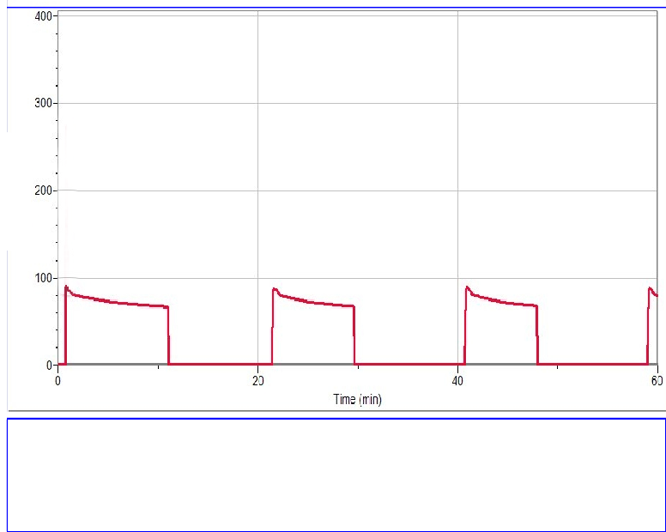
Electricity and Time-of-Use Pricing Lesson 7 The example appliances in the applet and
most of the appliances in your home are ei- ther off or on, but a few of the appliances in your home are more complicated.
One way to find out how an appliance uses energy is to take measurements using a home energy monitor like a Kill A Watt or Watts up? power meter.
Watts (W)
A refrigerator or freezer with a self de- frost cycle uses a heating coil to melt ice that has accumulated on the freezer coils. The heater is usually controlled by a timer and cycles on at regular intervals. The de- frost cycle is followed by the cooling cycle. The cooling cycle is controlled by a thermo-
This graph shows the power used by a small refrigerator. The refrigerator was plugged in to a Watts Up Pro power meter for an hour.
Time (min)
stat and runs whenever the temperature inside rises above the set temperature.
- How many times did the refrigerator in the example cycle on?
- How often and for how long did the cooling cycle operate?

- Estimate the kWh of energy used by this refrigerator during a 24 hour period.
- How could the design of the refrigerator be adjusted to minimize the energy it uses during peak times?

Survey your home’s energy needs.

- Count the number of electrical sockets in your home. What is the average number per room?

- Once in the morning, once in the afternoon, and once in the evening, list everything in your home that is using electricity. Make a note of how many of these items were running unnecessarily, such as a light when no one was in the room.

- Is there anything on your list that was used during peak times that could be used during off peak times instead?

- Prepare a presentation of your home’s energy needs. Be sure to include how energy is currently being used in your home and what you suggest might be done to improve energy efficiency in your home in the future.

TCIPG is funded by: The Department of Energy
The Department of Homeland Security http://tcipg.org
TCIPG Educational Development is a joint project of the Office for Mathematics, Science and Technology and Coordinated Sciences Laboratory at the University of Illinois.
These materials were developed by Judy Rocke, Jana Sebestik and Zeb Tate.
tcipg.mste.illinois.edu/

